**Introduction**

This user guide provides instructions on how to navigate and use the COVID-19 Awareness Website effectively. The website is designed to provide important information about COVID-19, including safety measures, symptoms, prevention methods, and more.

Website Overview

The website consists of multiple sections, each dedicated to a different aspect of COVID-19 awareness. The main sections include:

**Home**

. Protect

. Symptoms

. Prevent

. Handwash

. About Us

**Navigation**

The website has a fixed **header navigation bar** at the top of the page. Users can access different sections by clicking on the respective menu items:

* **Home:** General information and an introduction to COVID-19.
* **Protect:** Guidelines on how to protect yourself, including wearing masks, handwashing, and social distancing.
* **Symptoms:** Information on the common symptoms of COVID-19.
* **Prevent:** Steps to take to avoid infection.
* **Handwash:** Proper handwashing techniques.
* 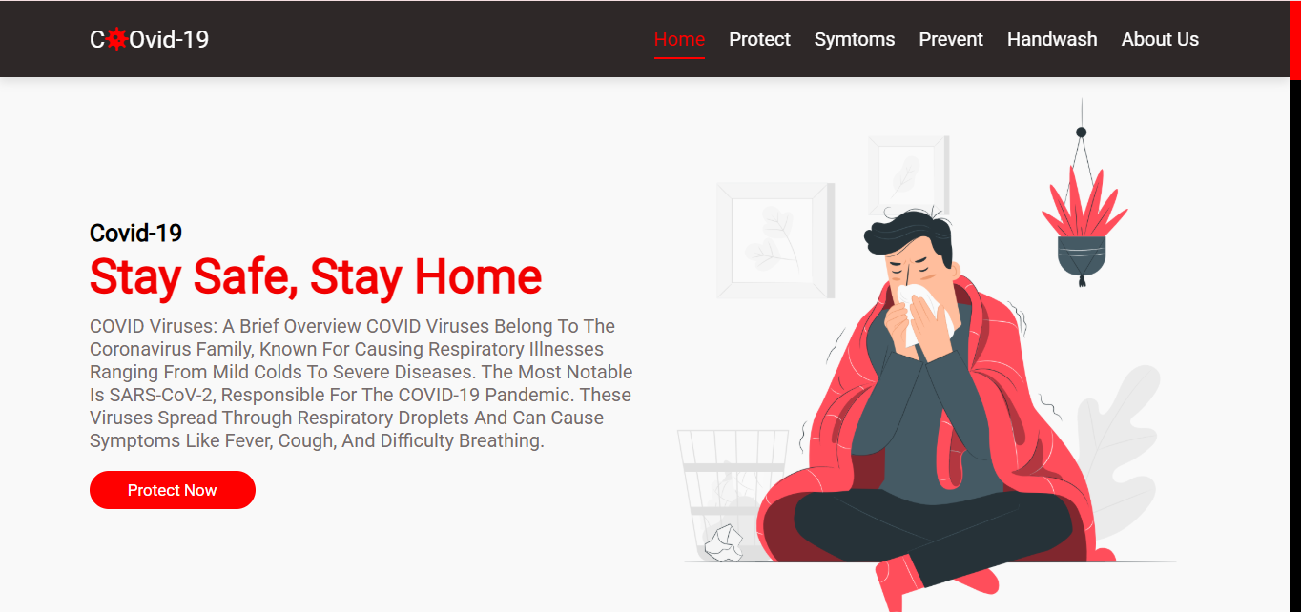**About Us:** Information about the creators of the website.

**Using the Features**

**1. Buttons**

Throughout the website, buttons labeled **"Learn More"** or **"Know More"** are available. Clicking these buttons will provide additional information on the selected topic.

**2. Image Sections**

Each section includes images to visually represent the information provided. These images help in understanding concepts such as social distancing, handwashing, and mask-wearing.

**3. Responsive Design**

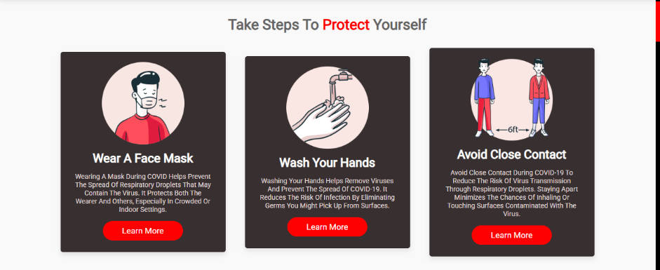The website is optimized for different devices, including desktops, tablets, and mobile phones. The layout adjusts dynamically based on screen size.

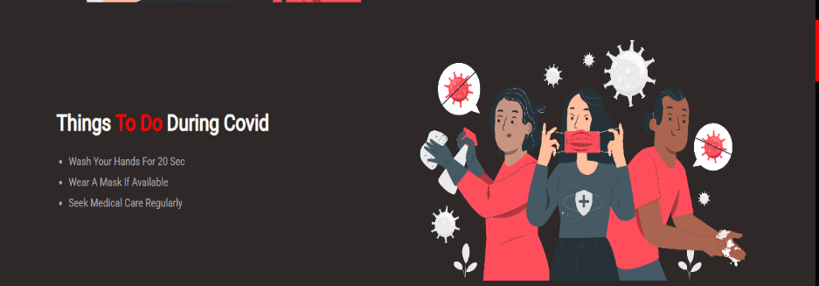

**Styling and Appearance**

The website has a professional and clean design, featuring:

* A dark-themed **header** with easy-to-read navigation links.
* A **red color scheme** for emphasis on important information.

**Best Practices for Usage**

* Ensure you scroll through all sections to gain complete knowledge about COVID-19.
* Use the navigation bar to quickly jump to the section of interest.
* Click on the provided buttons to access detailed information.
* 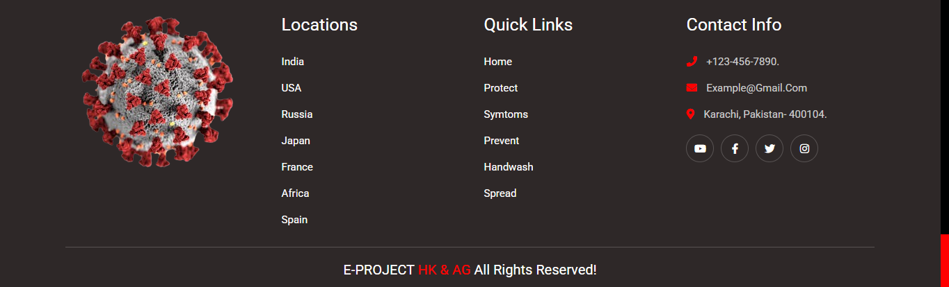Follow the safety guidelines mentioned to protect yourself and others from COVID-19.

**Troubleshooting & Support**

If you experience issues such as broken links, missing images, or navigation problems:

* Refresh the webpage.
* Check your internet connection.
* 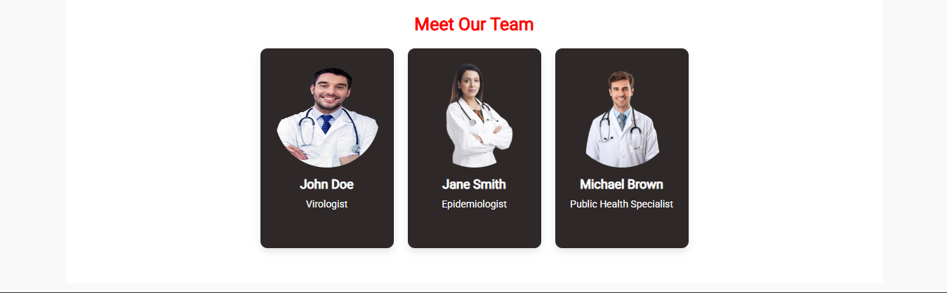Contact the website administrator for support.

**Conclusion**

This website serves as a valuable resource for learning about COVID-19 and its preventive measures. By following the guidelines, you can help reduce the spread of the virus and stay safe.

For more information, visit official health websites such as WHO or CDC.